**COMPUTER NETWORKS LAB**

**200960**

**NIMRA NOOR**

**BSCYS-3-B**

Question 01:

Calculate IP Addresses produced after applying the “formula (mathematical calculation for each IP)”.

Identify Class, Private/Public, Valid/Invalid and Reserved/Not Reserved for each of calculated IP

Address.

1. 1*Student-ID % 200. 1*Student-ID % 200. 1*Student-ID % 100. 1*Student-ID % 100.

2. 2*Student-ID % 200. 2*Student-ID % 200. 2*Student-ID % 100. 2*Student-ID % 100.

3. 3*Student-ID % 200. 3*Student-ID % 200. 3*Student-ID % 100. 3*Student-ID % 100.

4. 4*Student-ID % 200. 4*Student-ID % 200. 4*Student-ID % 100. 4*Student-ID % 100.

5. 5*Student-ID % 200. 5*Student-ID % 200. 5*Student-ID % 100. 5*Student-ID % 100.

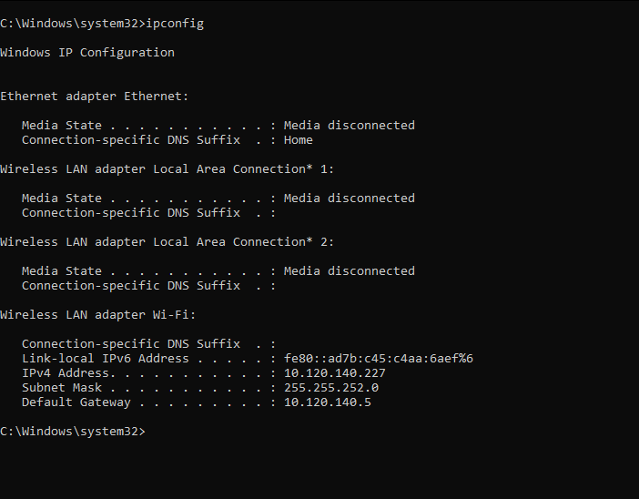

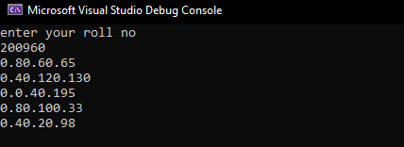

|  |  |  |  |
| --- | --- | --- | --- |
| IP | CLASS | USAGE | TYPE /STATUS |
| 0.80.60.65 | A | PUBLIC | VALID/NOT RESERVED |
| 0.40.120.130 | B | PUBLIC | VALID/NOT RESERVED |
| 0.0.40.195 | B | PUBLIC | VALID/NOT RESERVED |
| 0.80.100.33 | B | PUBLIC | VALID/NOT RESERVED |
| 0.40.20.98 | B | PUBLIC | VALID/NOT RESERVED |

Question 02:

Using the NET USER command perform the following:

1. Create a NEW USER.

a. Name format: exam name {Reg}

b. Example: examadnan201764

2. Assign the time of 11AM to 5PM for Monday to Friday.

3. Create New local group:

a. Name format: exam local group {Reg}

b. Example: examlocalgroup201764

4. Add User to the newly created local group

5. Display/View the information about the User

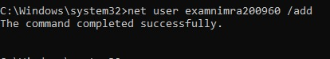

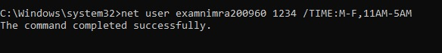

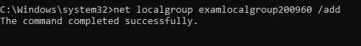

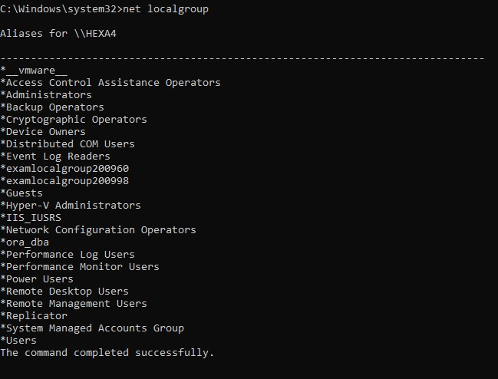

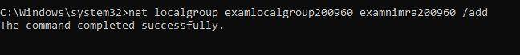

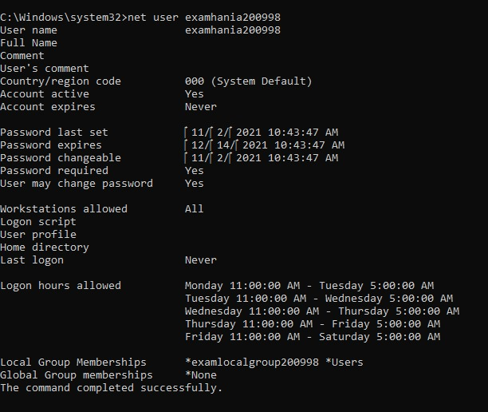

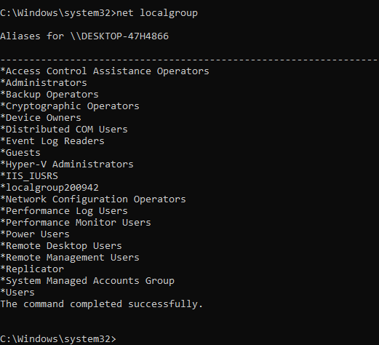

Question 03:

TASK-1: ROUTE

1. Display the route table

2. Find the “Gateway” for your network.

3. Using ROUTE command add a route with the following values:

a. Destination IP = Use IP of Google

i. Use PING to find IP of www.google.com

b. Gateway = {Your Network Gateway}

c. METRIC = 25

TASK-2: NETSH

Using NETSH command Display and Save the following:

1. Information about Network IP configuration

2. Information about all TCP Connections

3. Information about all UDP Connections

Task 01

Part 1

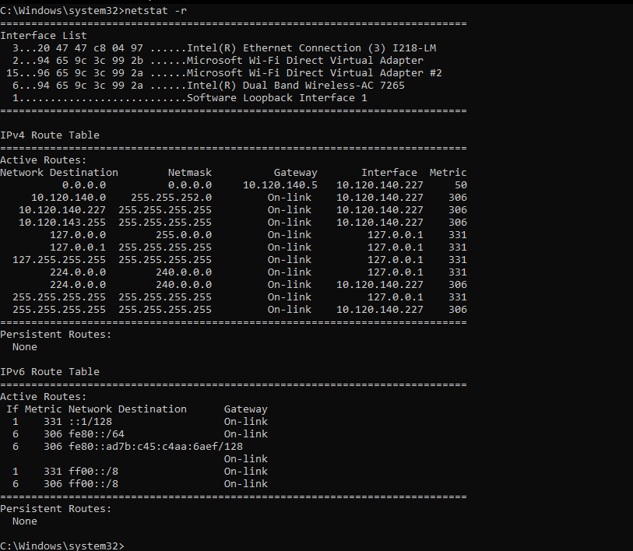

Part 3

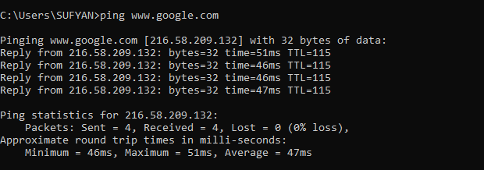

Part 2

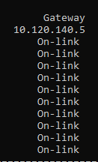 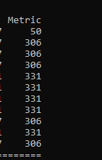

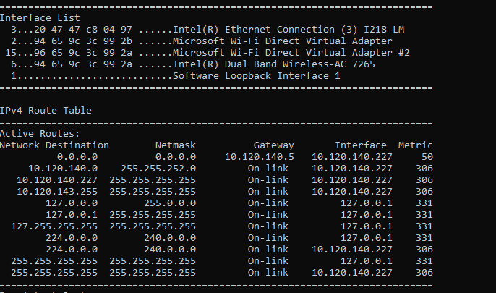

Task 02

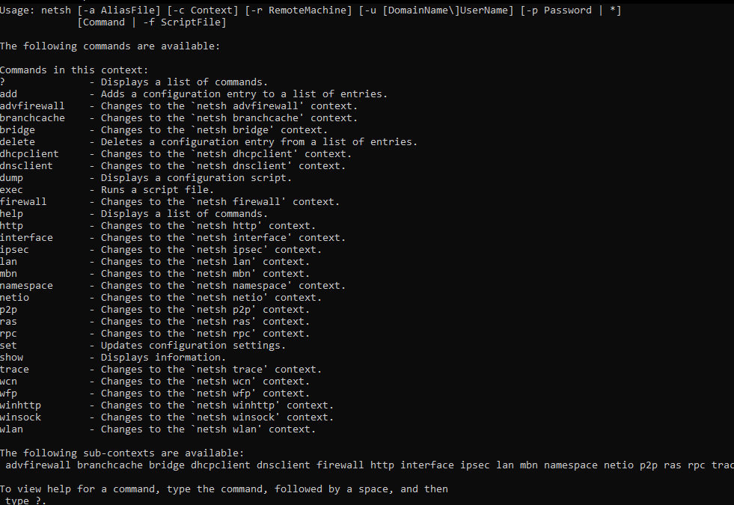

Part 1

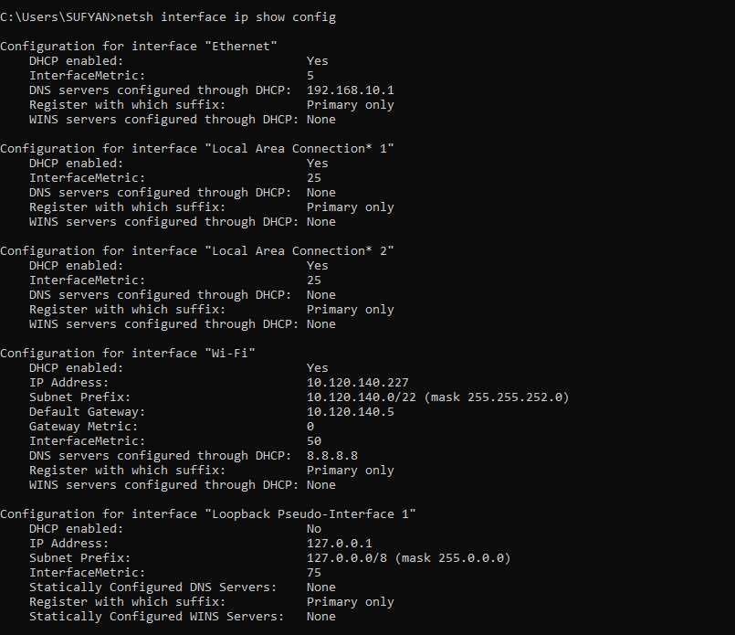

Part 2

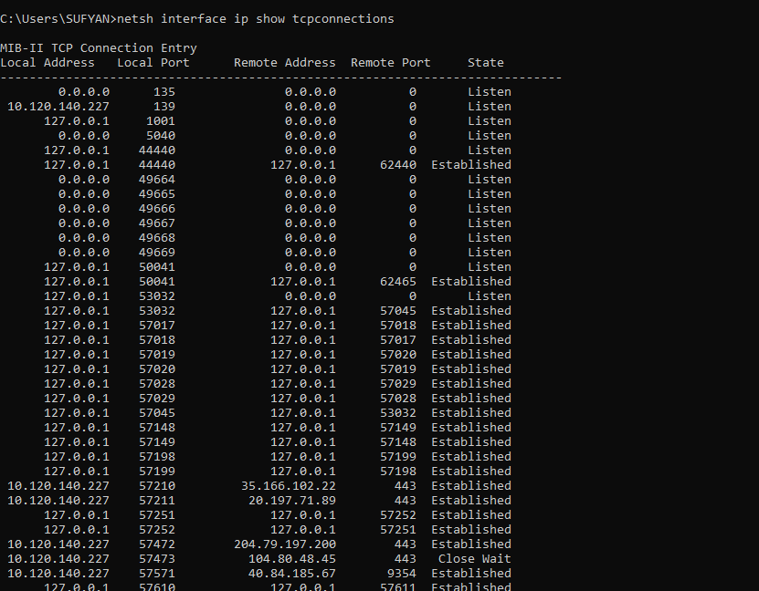

Part 3

